TECHNICAL REPORT: CDR ANALYZER
P.V.Mriya Munesh 25MSDFR039

I. Introduction:-
The call detail record analyzer is a data powered forensic tool designed to process, analyze, and visualize telecom call records for investigative purposes. The system focuses on identifying communication patterns, extracting network-level metadata (MCC, MNC, TAC, LAC), and detecting anomalies or suspicious behaviors. It can be helpful in forensic analysis aspects and law enforcement investigations.

II. Objectives:-
- To automate the analysis of large amount of CDR datasets.
- To extract telecom details like TAC,LAC,MCC,MNC and cellID.
- To identify call patterns and most called numbers.
- To flag suspicious calls and anomalies.
III. Layering:-
- Goes through the CDR dataset and cleans and structures it properly.
- Does pattern detection and computes the data.
- Displays the data in the form of graphs and a website with friendly UI dashboard.

IV. Libraries used and why? :-
- Pandas:
It enables easy handling of large amounts of datasets, including filtering, grouping and separating data accordingly. It helps to extract patterns like most called numbers and frequency distributions.
- Matplotlib:
It is essential to create graphs which show call frequency charts and anomaly distributions. It converts raw data to interpretable visual data.
- PyPAT:
It is a pattern analysis tool hence it helps to identify unusual calling behavior, any repetitive patterns or irregularity which indicates suspicious activity.

- Streamlit:
This tool helps in deploying a working dashboard with user friendly UI on a website, where the dataset can be uploaded and the website will give the necessary details.
- Parser:
This tool is essential to parse the raw data into structured tables. It segregates the data into proper tables for easy analysis.

- PyDOC:
It documents the codes and makes it easier to access and maintain for future uses as well.

V.Data fields and parameters :
- MCC:-
The mobile country code identifies the country of the mobile subscriber, it helps in knowing international communications.
- MNC:-
The mobile network code identifies the telecom operator and helps to pinpoint calls to the specific service providers.
- TAC:-
Tracking area code is used to identify tracking areas and additionally helps track movement patterns of a device.

- LAC:-
Location area code, it helps in identifying a specific location within a network, it helps in geographical profiling.

VI. Modules:-
- Data loading and cleaning
Reads CDR data from the Excel sheet files. It segregates the columns properly and removes inconsistent values or entries.

- Frequency analysis:
It identifies most dialed numbers and most received calls and additionally helps detect primary contacts in communication.

- Metadata extraction:
Extracts mcc, mnc, tac and lac from datasets. Maps the location and geo location and supports forensic tracing of the evidence.

- Visualization:
It creates bar graphs and time based call distribution charts.
- Anomalies:
It detects unusual spikes in call activity, repeated calls to specific numbers and calls at irregular times.
VII Suspicious call identification:
VIII Dashboard features:
- Upload CDR dataset
- View summarized statistics
- Display top contacts
- Visualize call patterns
- Highlight suspicious activities
IX Limitations:
- Limited real-time tracking capability
- External databases required for full MCC/MNC mapping

X Enhancements in the future:
- Integration with live telecom APIs
- AI-based anomaly detection models
- Geolocation mapping using cell tower databases
- Automated forensic report generation

XI Conclusion:
The CDR Analyzer is a powerful forensic tool for telecom data analysis. By combining data processing, visualization, and anomaly detection, it enables investigators to uncover hidden communication patterns and potential threats effectively.

Screenshots:- (i)CDR folder created with the python script and application script with the graphs and data set.
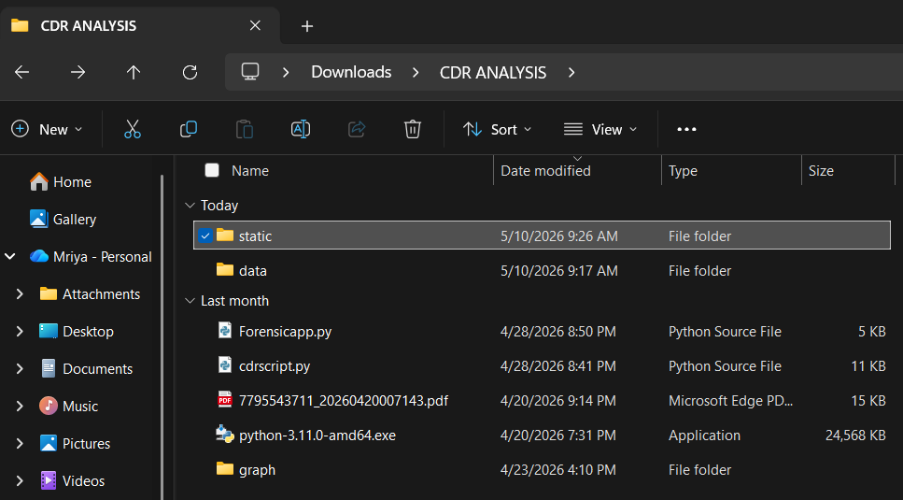
(ii)The dataset for the CDR analysis in excel format.
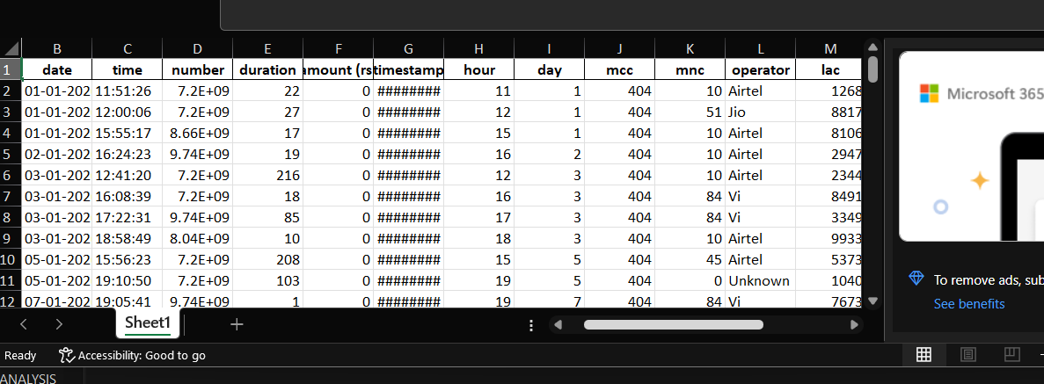
(iii)Running of the CDR script by the command “python cdrscript.py”.
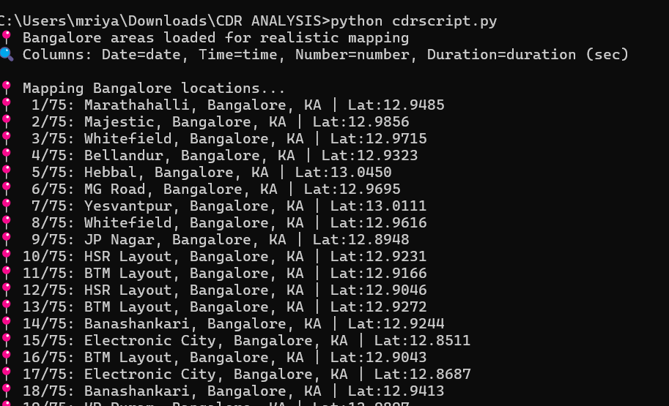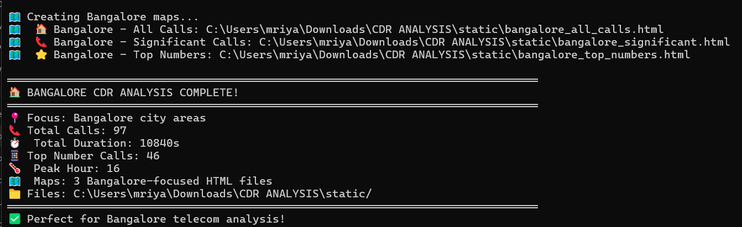
(iv)Running of the cdr application with the command “streamlit run ‘Forensicapp.py’.
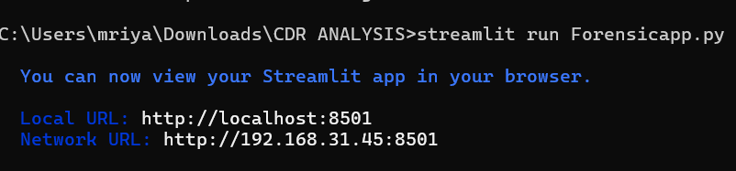
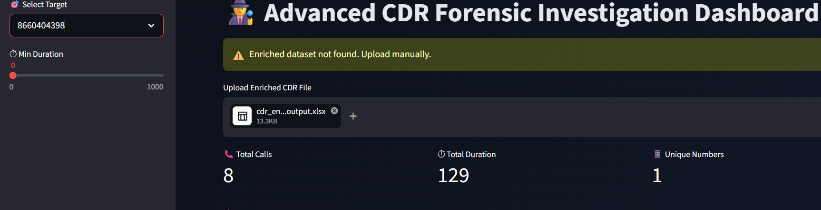
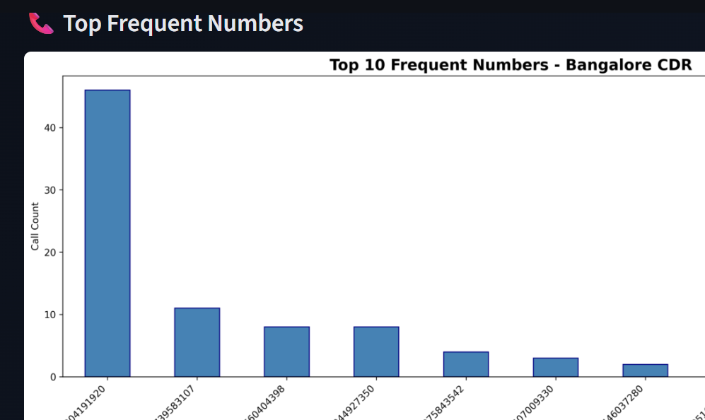
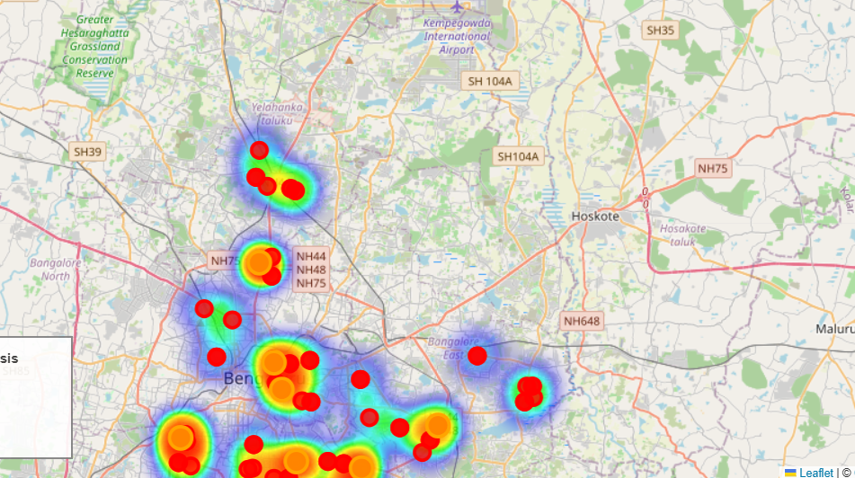
Application showing location map, frequent call data in graph format and specific number calls.
(v)The graphs are saved in the folder called “static”.
